December 2024

Greetings Homeowners,
I have attached before and after pictures of the refurbished landscape areas for those of you who have not made it out to Parker since the end of October. The only thing left to do is hook up the water valve and sprinklers for the eventual plants we will install along the Buckskin chain-link fence to obscure the view of the plant and hopefully mitigate some of the smell; and a few decorative plants in the rock along 1 - 9 (spring 2025). Our goal for the landscaping was to tie together the esthetic throughout the property, cover dirt areas, hopefully control water flow to prevent erosion and keep long term landscaping costs down. Lastly, the dog poop station was moved towards unit #9 right off the red path to make it easier for owners to access the baggies for clean up and disposal as they enter and exit the walkway. I don’t have pictures for all of the areas in both before and after, but the entire property is now landscaped and we are in compliance with our CC&R’s. The final page is an audit of all expenses on both projects.
So far, all reviews from owners, renters and visitors to the property have been extremely positive.
Our trees were trimmed and pre-emergent weed spray laid down in the entrance area and the middle common area. We will evaluate the success of this procedure in the summer and decide if pre-emergent spraying needs to be done in both the spring and fall in the future.
The consensus from homeowners seems to be to move on to painting our units. We will be reviewing the quotes again at our next meeting in January and voting on whether to put forward a special assessment vote to the community to get the required painting done. We will need to have some repair work done before the painting to some of the pool fencing that has rusted through. Also, the pool area MUST be included in the painting project, I just don’t think it can hold up another summer without sustaining major damage to the wood. Replacing the cabana would be very costly compared to painting and reroofing. It would be best to start the painting project with the cabana area by May and then, as we wait for money to come in, do our units in the fall. I have included some pictures at the end to prove the point. I am going to see if we can get a quote for an awning of some kind to cover the cabana area rather than reinvesting in 1 X 2’s that have a tough time holding up in the heat without warping and peeling. Painting will be a big investment for each of us as homeowners to do the entire community project, but it is necessary to maintain our property while we continue to build our reserves for the future. Saving is hard, but the only way Sandpiper can survive is to NOT spend money out of our reserves until we can build it to a point where whatever we take out can be replenished within 3 to 5 years. Please closely review the pictures of the pool cabana area to see the inherent problems that need to be addressed as soon as possible.
As a community, we have banded together and have done projects and amendments that have moved our community forward in a positive direction, we have also carefully used our association money to maximize the benefit for the entire community. The big things hanging over our heads are the exterior painting, the roofs and streets. It’s a lot; but we only need to bite off one thing at a time and know that every investment we make will pay off for us all in the long run. There is only so much property along the river and we have a prime spot with great views. I hope all of you will see the value in continuing to invest in the long term and enjoy the benefits of each achievement as they are completed while we save for the future. If we can quickly pass a special assessment and get 80 percent of the money in by fall, we can look forward to next years holidays with a beautiful new esthetic.
When I took over, we had $36,000 in our Reserve Account at the end of December, we are looking at almost $85,000. We did not spend any money out of our reserves to pay for the landscaping projects. We have been saving money in our checking account to cover the costs.
We moved $50,000 from the Reserve Account and split it into 2 CD’s that offer a better interest rate than a regular savings account and we will continue to look for safe ways to maximize our money. This year we will be increasing the amount we put in our reserve account to help cover future expenses. It would be nice in the future to just show up at meetings and just be able to plan for the things needed for maintenance and to keep our property up without needing special assessments. I estimate the amount we would need in reserves to do this would be around $500,000 to $750,000. Needless to say, it will take quite some time (at least 10 years) to accumulate this money and aggressive savings, but it can be done! Once we have a robust savings; projects can be completed and money returned to replenish our Reserves for the next project that comes along on a regular schedule. If we can stick to our savings plan, we should be able to move forward without special assessments in 10 years time. We are still working on a comprehensive Reserve Study; currently we require 1.2 million for a fully funded Reserve Account, but we have other items we are still adding to the list and the amount required will increase a bit more. One of the benefits of having a healthy Reserve Account will pay off when we shop insurance; companies we deal with want to know that we can maintain our property. The insurance industry is changing rapidly and we will need to be prepared for potential future legislation regarding funding of reserve accounts.

Wishing you all the best of the Holiday Season and success to Sandpiper.

Audrey von Zabern
President

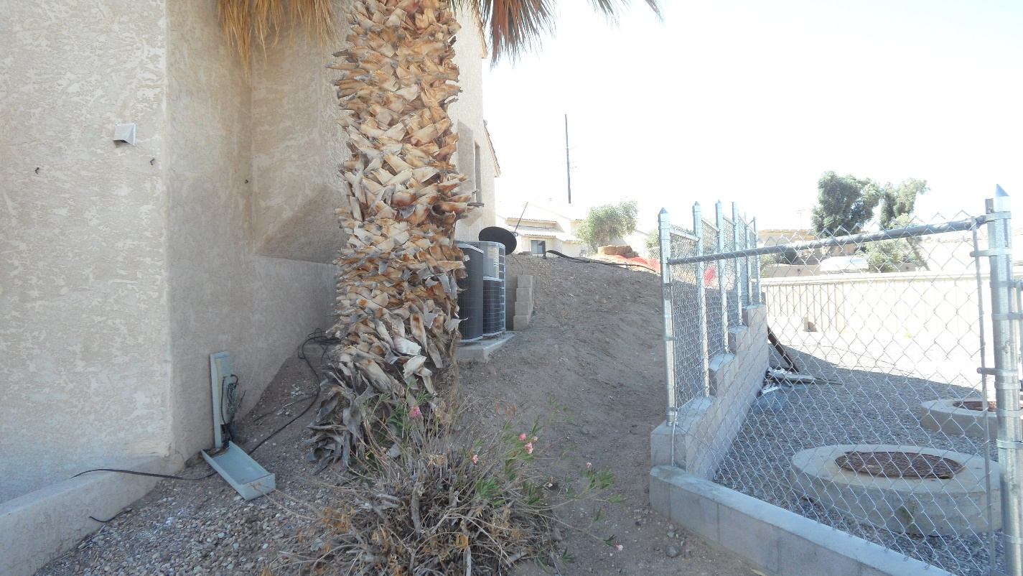
NEXT TO UNIT & BUCKSKIN - BEFORE

AFTER
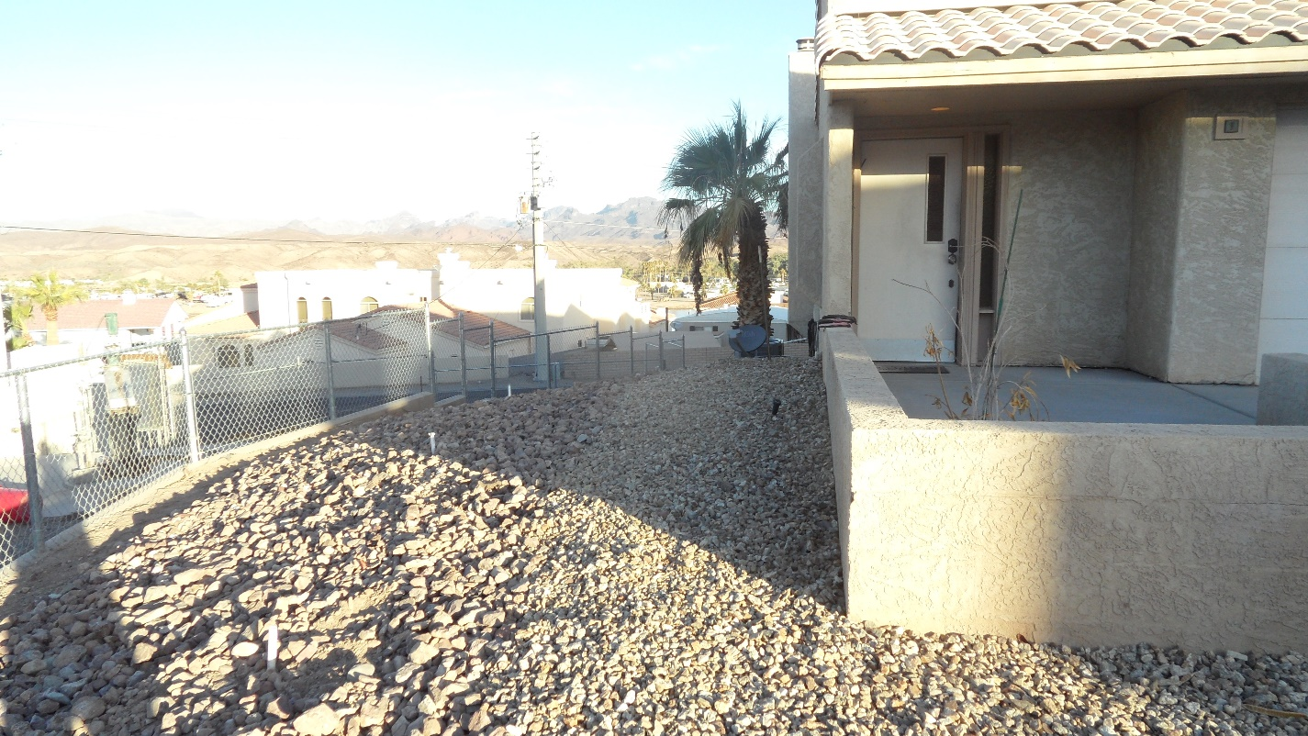
BEHIND UNITS 1-8 – BEFORE
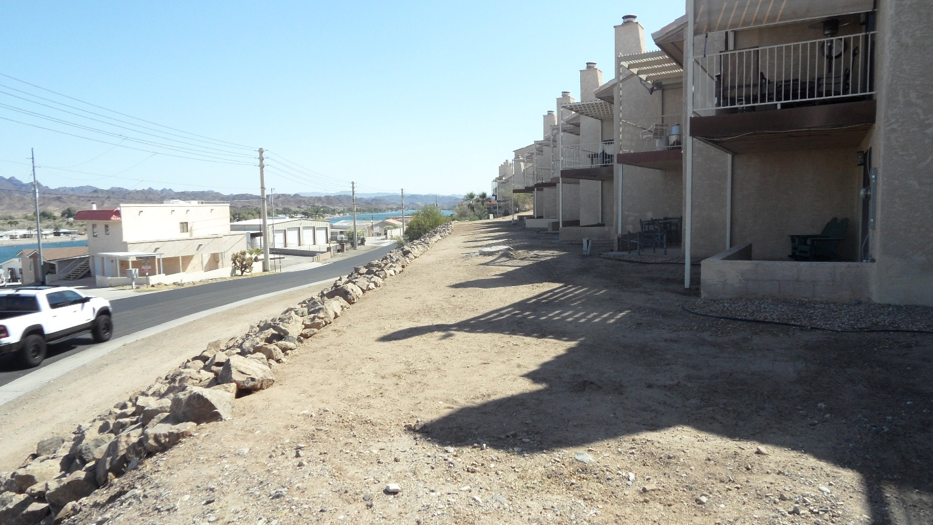

AFTER

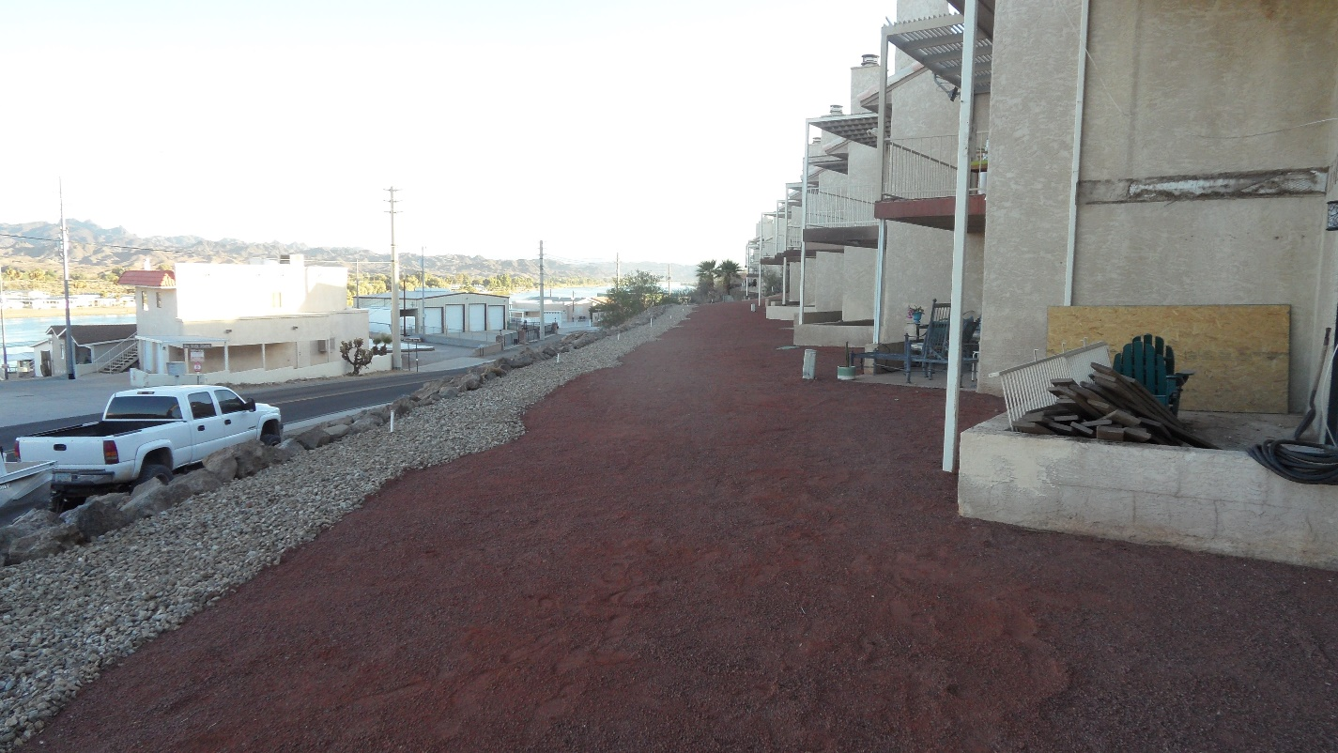
LOOKING FROM UNIT 8 TO UNIT 1
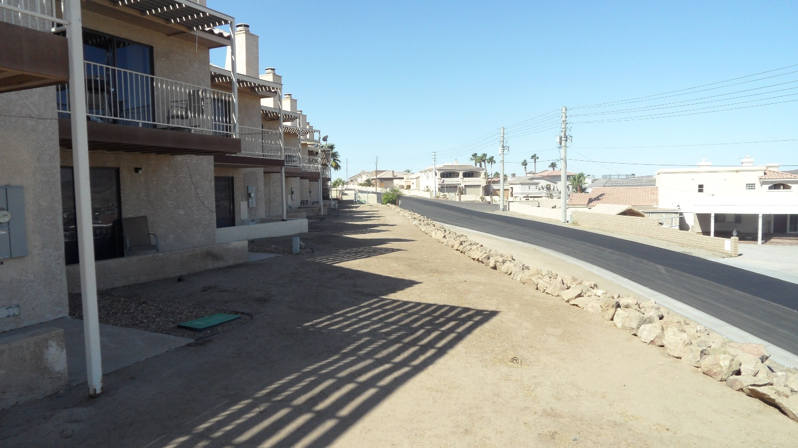

AFTER
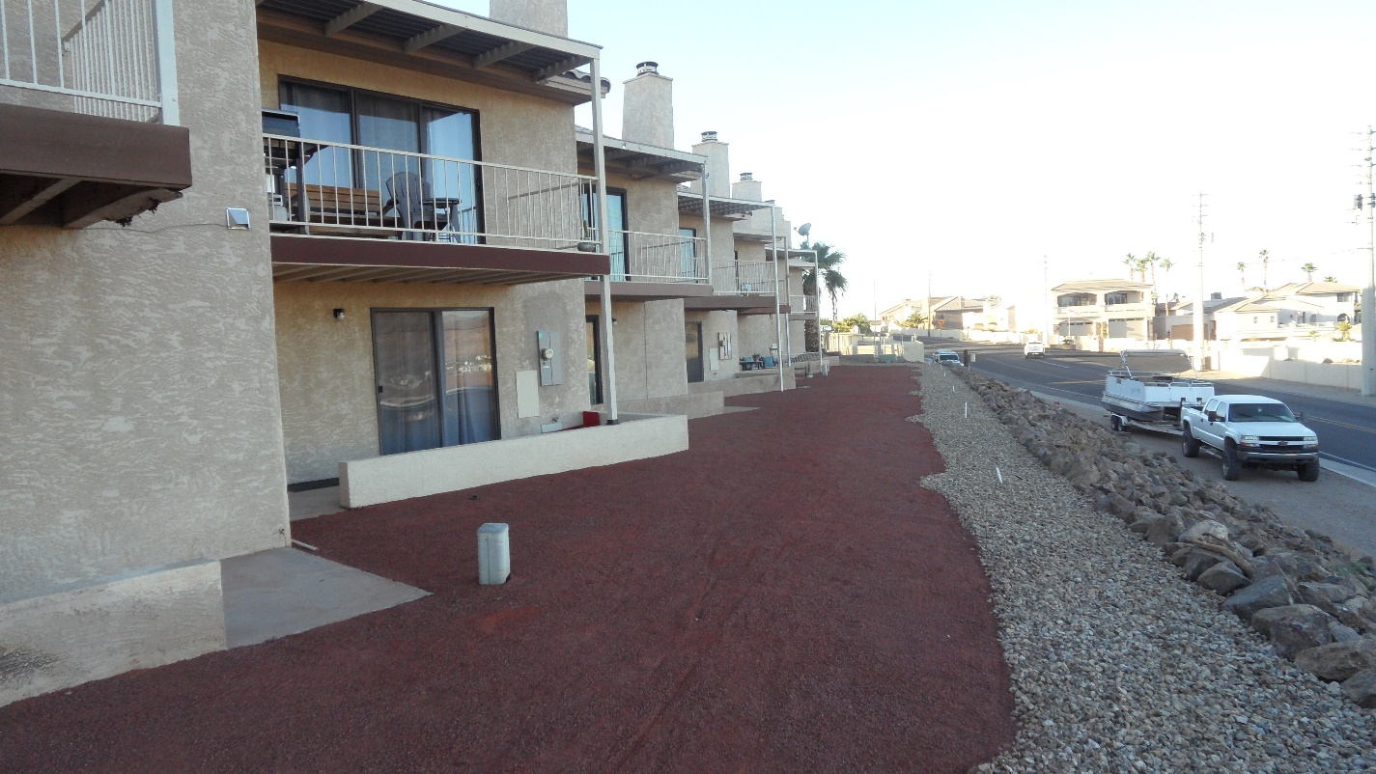

BETWEEN UNITS 8 & 9 - BEFORE
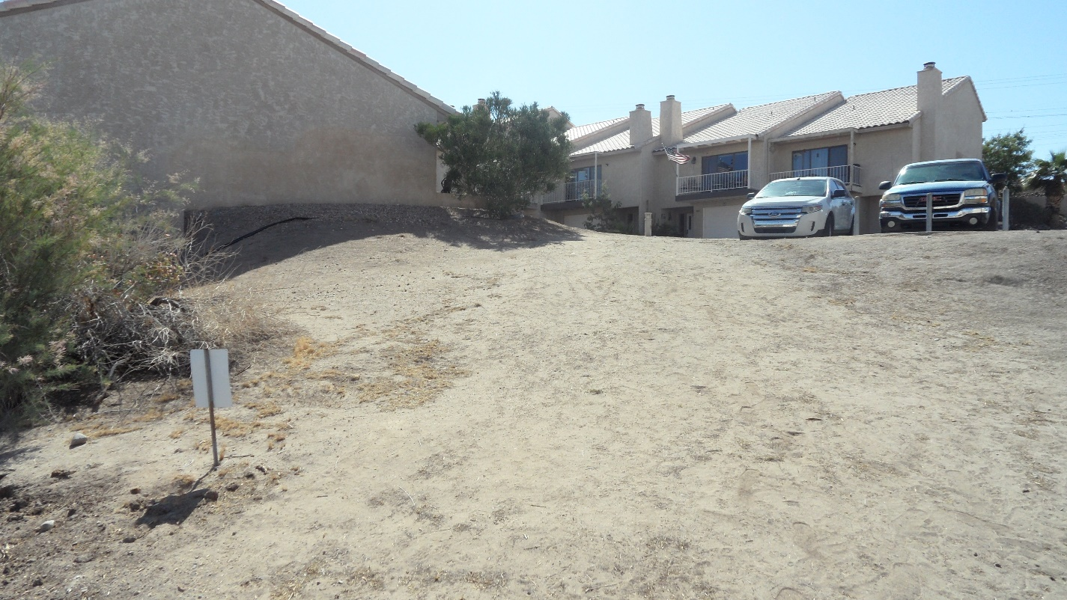

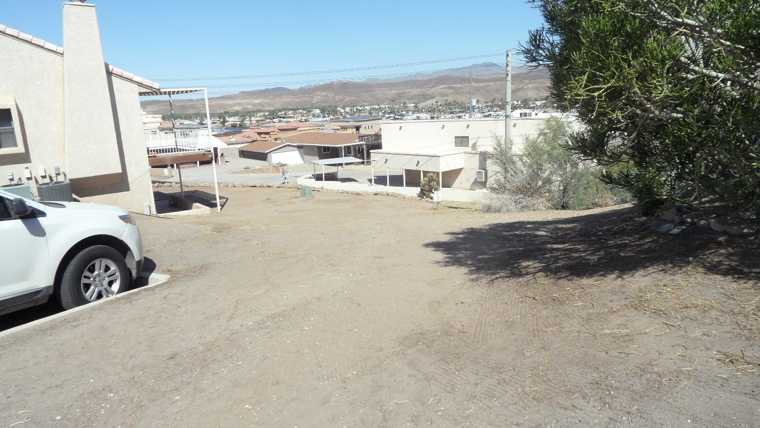

AFTER
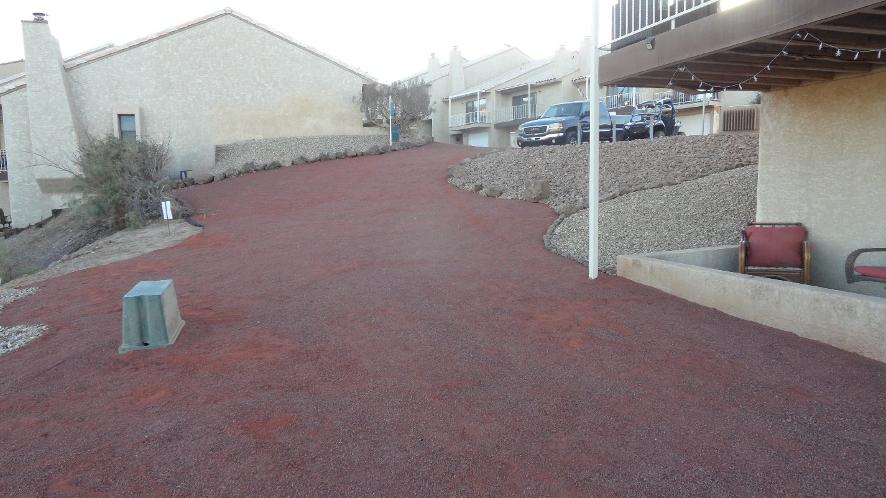

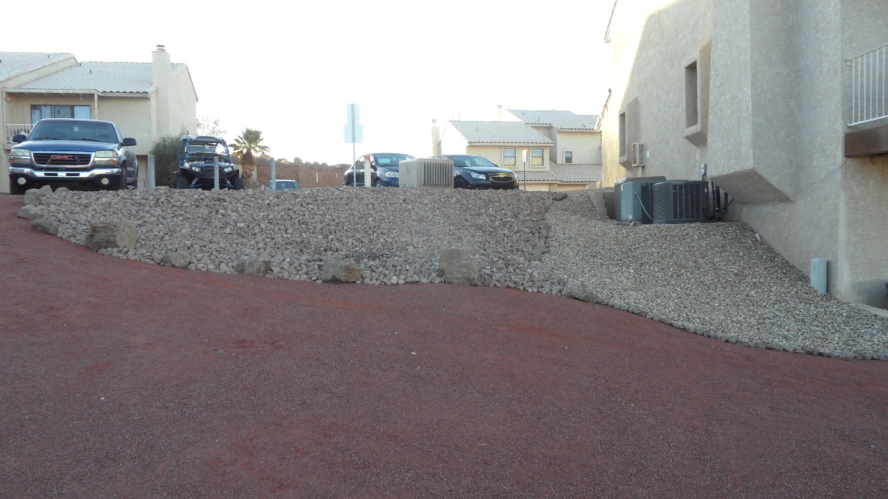

NEXT TO UNIT #14 – BEFORE
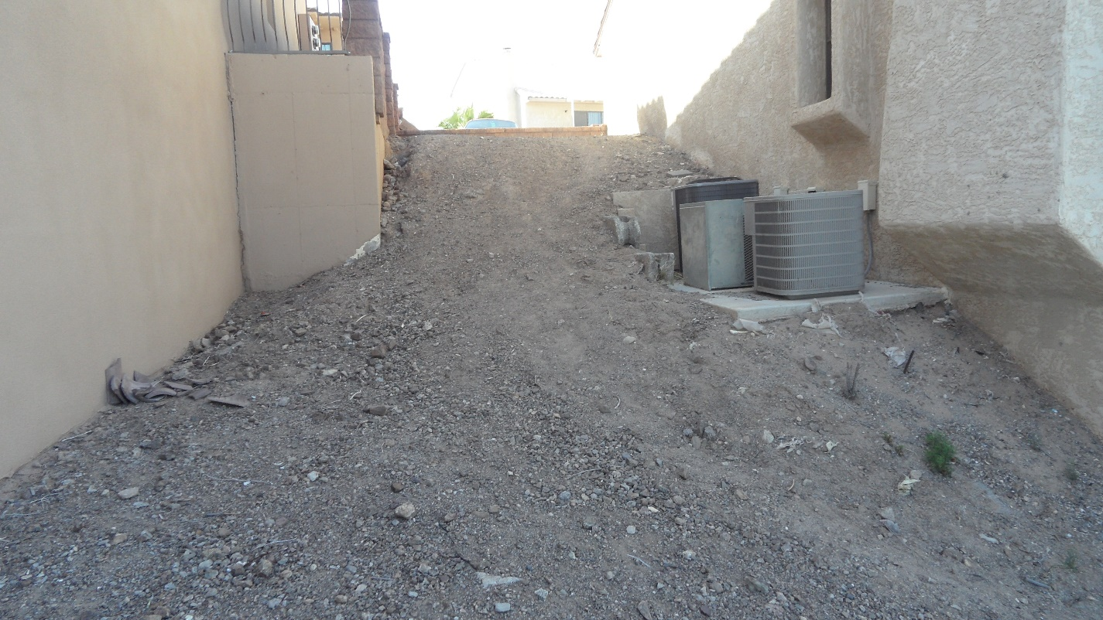

AFTER
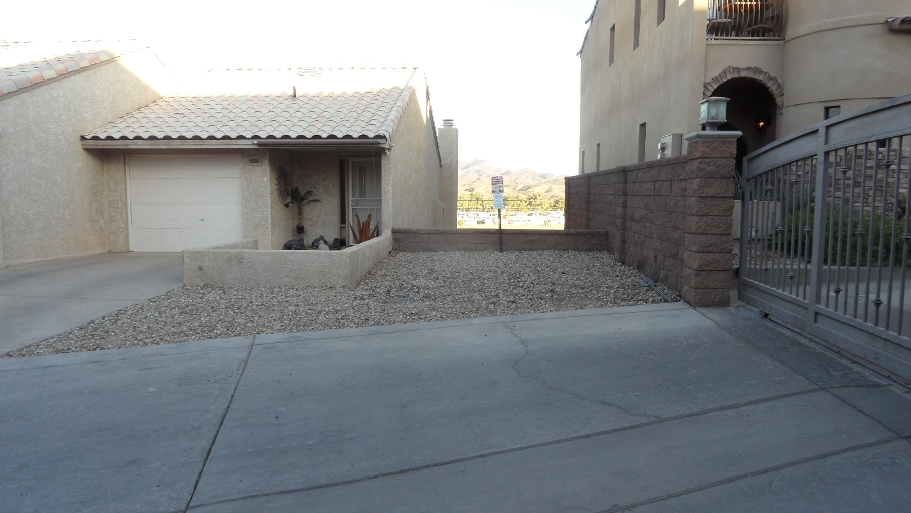
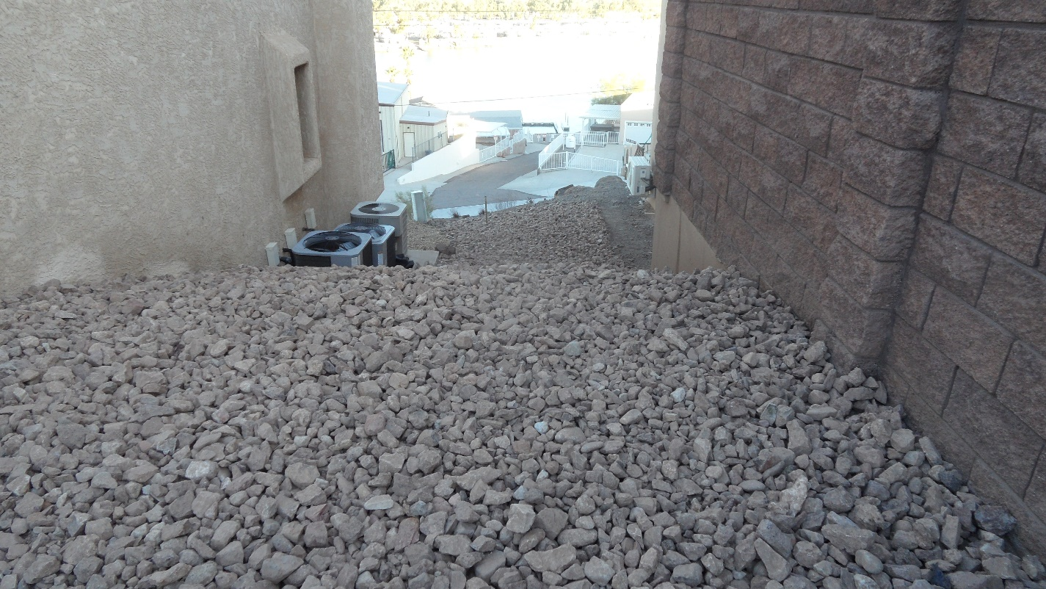

NEXT TO UNIT #37 – NO BEFORE PICS OF DIRT

AFTER
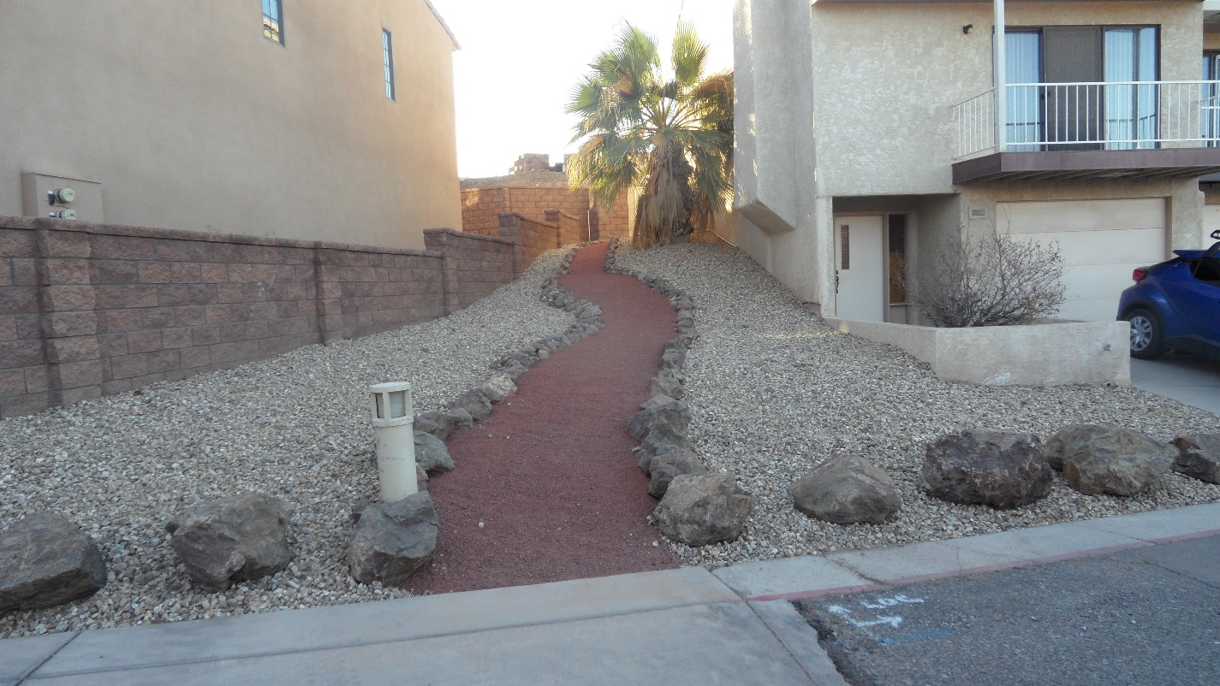

FRONTS OF UNITS AFTER SCRAPING OLD ROCK & ADDING NEW ROCK
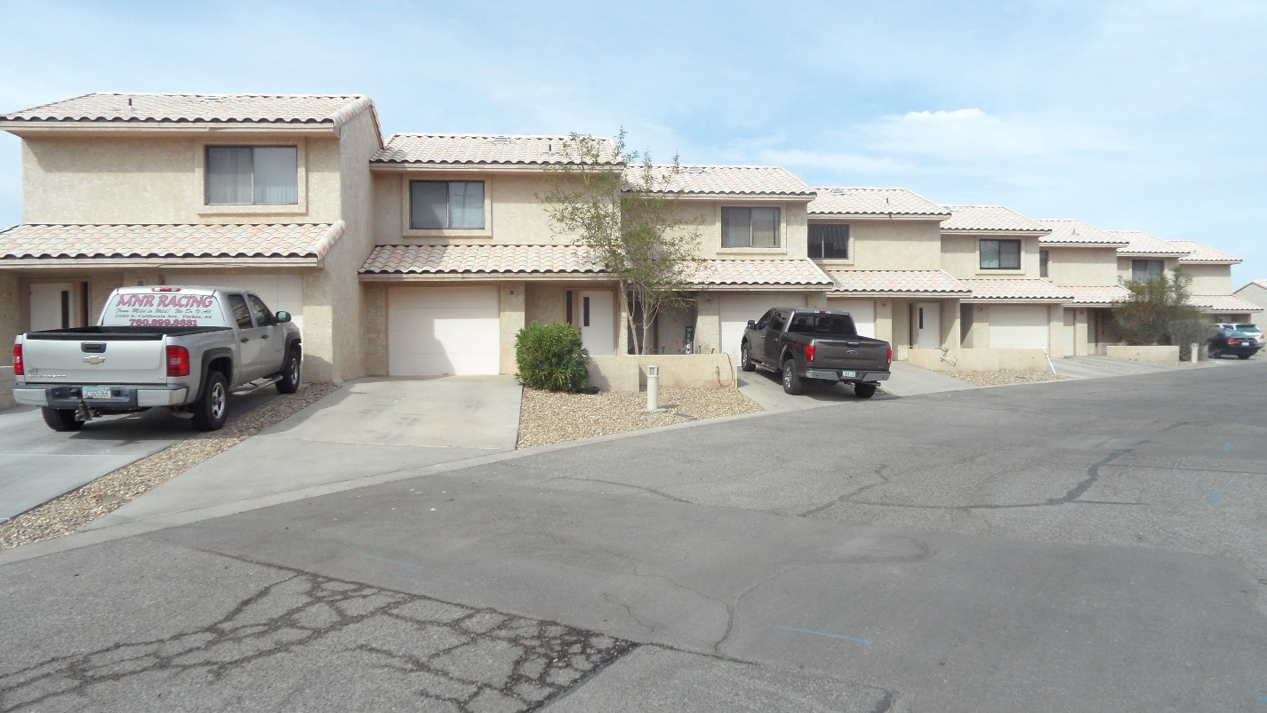
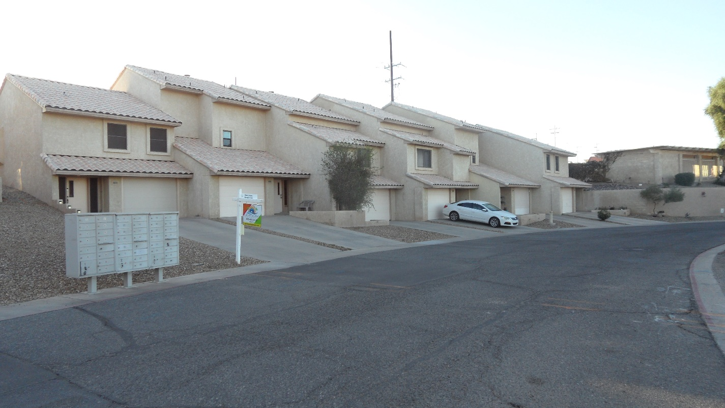
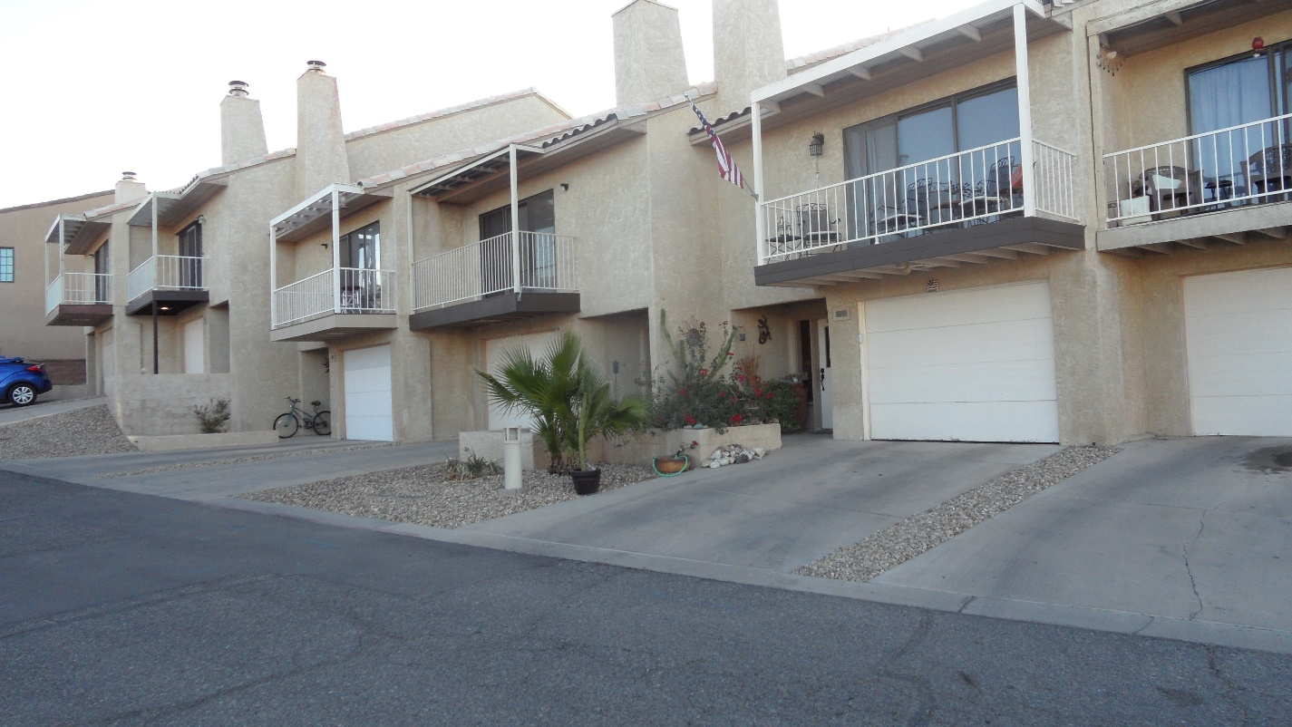
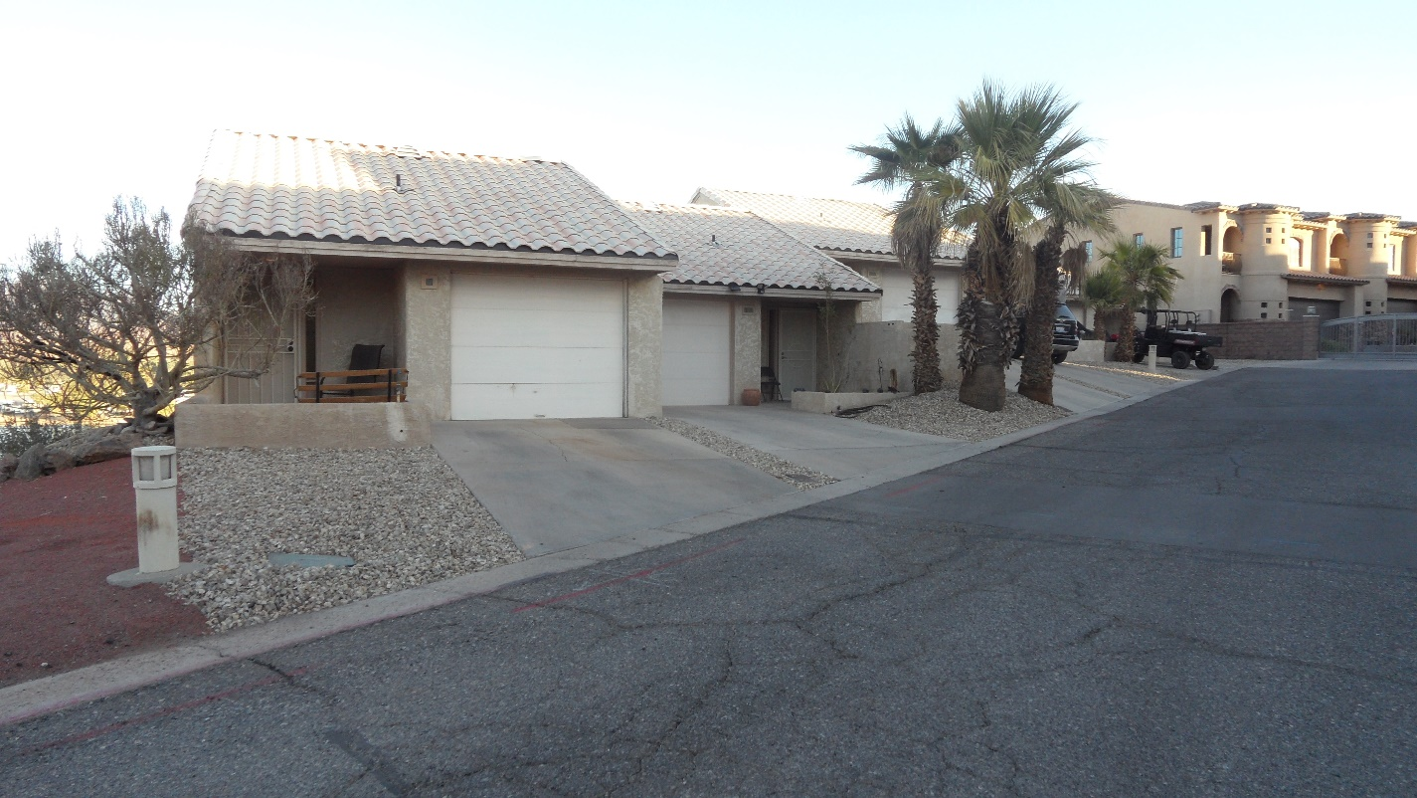

UNDER POOL WALL
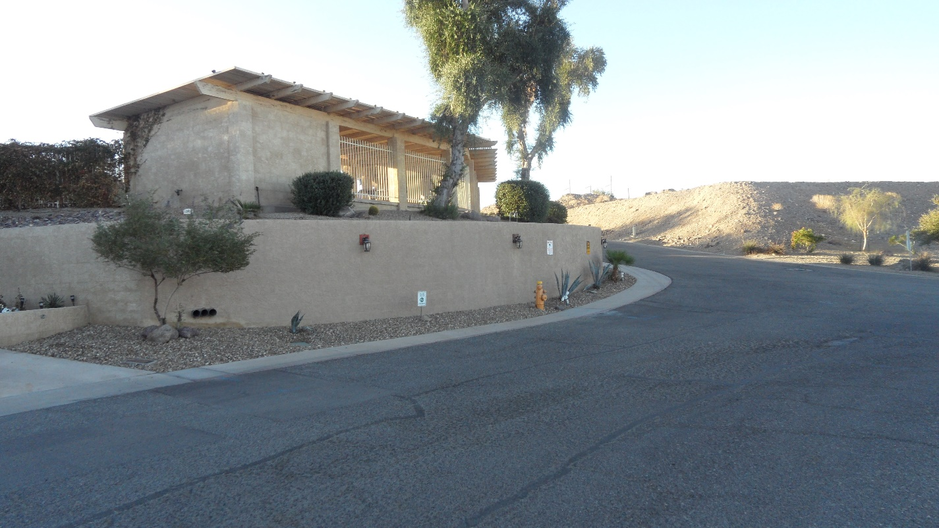
POOL AREA – NO BEFORE DIRT PICTURES
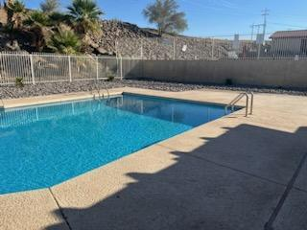
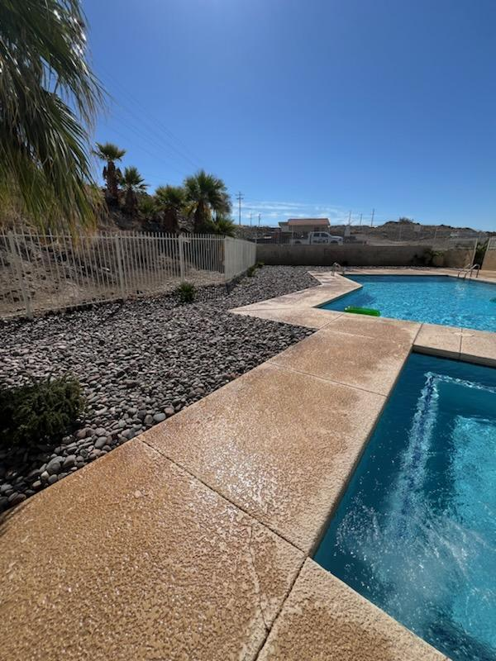

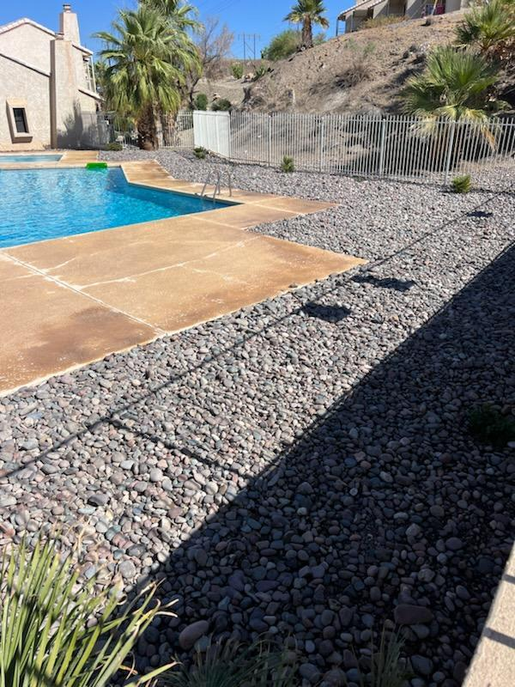

WATER DAMAGE FROM S.E. CORP PIPE BREAK – BEFORE
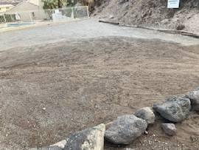
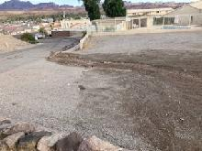

AFTER

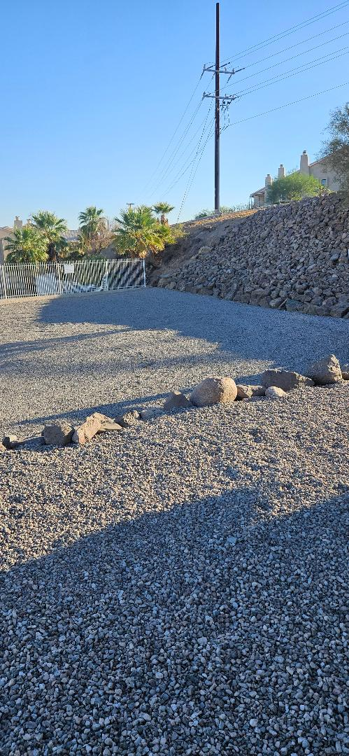

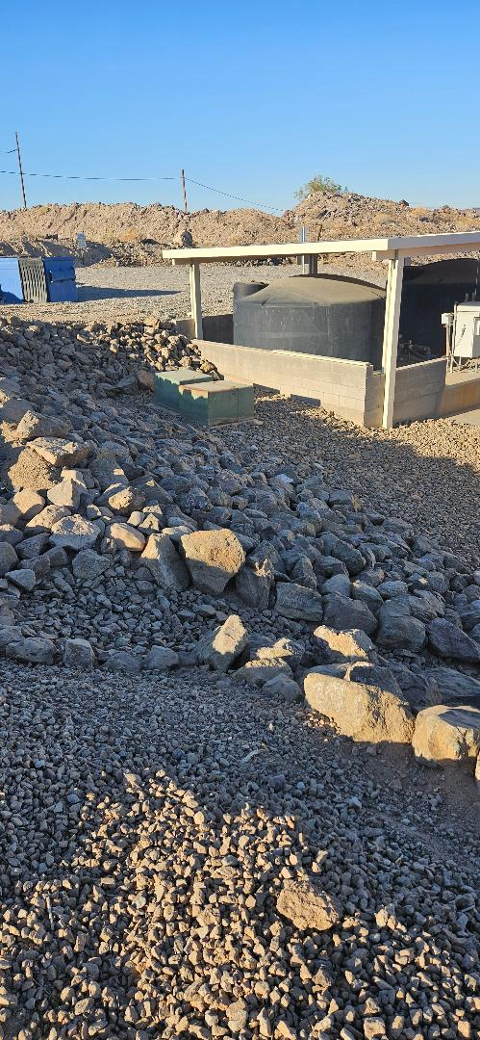
SANDPIPER LANDSCAPING COSTS 2024

Special Assessment income ($329.00 per Unit) $12,502.00
Insurance Reimbursement for Damage $13,944.66
Sandpiper Transfer from 2023 Profit $10,000.00
Donation for Buckskin Rock $533.00
Total Income for projects $36,979.66

Expenses
Irrigation Damage
Wally Saunders -$310.00
Van Rooy’s Plumbing -$608.14
River Legacy Water -$350.00
River Legacy Rock Purchase -$3100.00
Mike’s Landscaping -$14,250.00
Attorney Fees -$3,888.90
Total Damage Repair Expenses -22,507.04

Final Landscaping Restoration Project
Corey’s Landscaping (Pool Area) -1,485.00
Site Flight -$34,387.35
Buckskin Rock -$533.00
Corey’s Landscaping – Planting TBD
Current Cost of Landscape Restoration -$36,405.35

Both Projects Total -$58,912.39
Income +$36,979.66

Total Cost to Sandpiper 2024 $21,932.73
Pool Cabana Area:
